**Veda International School**

**Kusugal Road, Hubballi Ph: 0836-2002275**

(ICSE Board)

**WORKSHEET**

**Name: ___________________ Subject: EVS Date: _____________**

**Roll No : __________________ Grade : II**

**Teacher Sign : ______________________ Total Marks: 10M**



**Q-1) 3M**

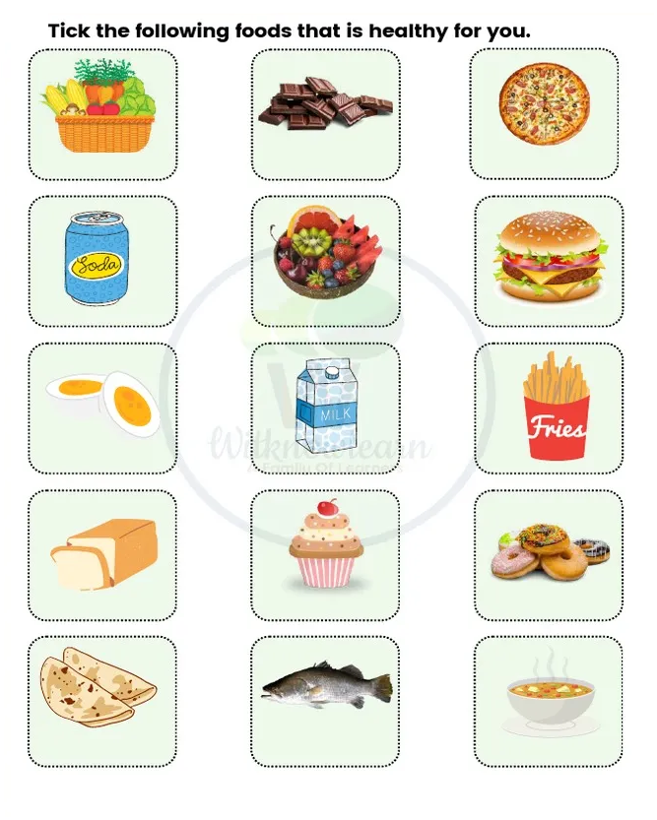**Q-2) 3M**

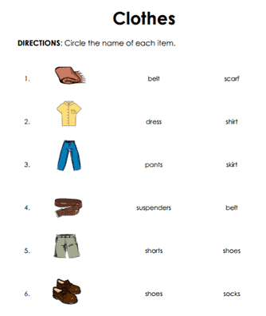**Q-3) 4 M**