 Veda International School

**Kusugal Road, Hubballi Ph: 0836-2002275**

**(ICSE Board )**

Chapter-5

GRADE:5 Topic: Pollination Month:August

Subject: Science

Q.I New words:

1. **Pollination**
2. **Androecium**
3. **Corolla**
4. **Calyx**
5. **Gynoecium**
6. **Filament**
7. **Stigma**
8. **Anther**
9. **Reproduction**
10. **Monosexual flowers**
11. **Bisexual flowers**
12. **Style**
13. **Whorls**
14. **Slender**
15. **Pollen grains**

Inbuilt Questions Textbook Exercises

Exercise For Revision Page No. 43

A. Tick() the correct answers.

1. (c) 2. (c) 3. (d) 4. (a)

B. Circle the odd ones.

1. lily 2. Watermelon

Exercise For Revision Page No. 45

Fill in the blanks.

1. pollination 2. pollen grains 3. self 4. cross

Exercise

A. Short Answer Questions:

Q1. What are the agents of pollination?

Ans: The agents of pollination are air, water, insects and animals.

Q2. What ios the function of calyx and corolla?

Ans: Calyx protects the flower during the bud stage while, corolla attracts the insects towards the flower.

Q3. Name the various parts of the androecium and gynoecium.

Ans: The parts of androecium are anther and filament. The parts of gynoecium are-stigma, style and ovary.

Q4. Why is pollination important for plants?

Ans: The pollination is important for plants as it helps in production of fruits and seeds.

B. Long Answer Questions:

Q1. Describe the structure of male and female reproductive parts of a flower.

1. Male reproductive parts of a flower (Androecium):

Androecium is made of many stamens. A stamen has two parts-filament and anther. The long and slender stalk is called filament. The lobed structure present on the top of the filament is called anther. Anther has pollen grains.

Female reproductive parts of a flower (Gynoecium):

Gynoecium is made of a single or many pistils. A pistil has three parts-stigma, style and ovary. Ovary has ovules. These ovules contain the female reproductive cells or eggs.

Q2. What are monosexual and bisexual flowers? Give two examples of each.

Ans: Monosexual flowers: The flowers that contain either pistil or stamens are called monosexual flowers. E.g.- flowers of papaya, watermelon and pumpkin.

Bisexual flowers: The flowers that contain both pistil and stamens are called bisexual flowers. E.g.- Rose and mustard flower.

Q3. Describe the process of pollination.

Ans: When the anthers of a flowers mature, they burst open. The pollen grains fall on the stigma of the same flower or another flower of the same plant. Pollen grains are also get carried to the stigma of a flower of another plant through wind, water or insects. This is how pollination occurs.

Q4. Differences between self pollination and cross pollination.

Ans: Difference between self pollination and cross pollination-

**Self pollination**

When pollen grains are transferred from the anther of a flower to the stigma of same or another flower of the same plant, it is called self pollination. E.g.-pollination in pea

**Cross pollination**

When pollen grains are transferred from the anther of a flower of one plant to the stigma by a flower of another plant, it is called cross pollination. E.g.- pollination in rose, grass and wheat

Q5. What will happen to plants and animals if pollination does not occur?

5. The absence of pollination can lead to a decline in plant reproduction, seed production, and food sources for animals, ultimately impacting the ecological balance in ecosystems.

**Application/Skill-based Questions: (Reasoning Based Questions)**

**E. Think and Answer:**

Q1. In flower ‘x’, self pollination takes place. What type of flower is it- monosexual or bisexual ? Give reason for the same.

Ans: The flower 'X' is likely bisexual.

Reason: In botanical terms, a bisexual flower (also known as a perfect flower) is one that contains both male (androecium) and female (gynoecium) reproductive organs. If self-pollination takes place in flower 'X,' it implies that the flower has both male and female parts, allowing it to perform self-fertilization. Monoecious plants, on the other hand, have separate male and female flowers on the same plant, while dioecious plants have male and female flowers on different plants. Since 'X' can self-pollinate, it suggests the presence of both reproductive organs within the same flower, making it bisexual.

Q2. In some some plants, the flowers have stigma generally sticky in nature. Give reason.

Ans: The sticky nature of the stigma in some plants serves as an adaptation to facilitate pollination.

Reason: The stickiness of the stigma enhances the chances of pollen adherence and successful pollination. When a pollinator, such as an insect or bird, visits the flower to collect nectar or pollen, the sticky stigma ensures that pollen grains adhere to it. This increases the likelihood of successful pollen transfer to the stigma, promoting fertilization. The stickiness prevents pollen from being easily dislodged by wind or other environmental factors, increasing the efficiency of pollination and the plant's reproductive success.

D. Name the following and also label in the given picture of a flower:

1. The part that protects the flower in the bud stage: ***Calyx***

2. The part that attract insects:  ***Corolla***

3. The male reproductive part: ***Androecium***

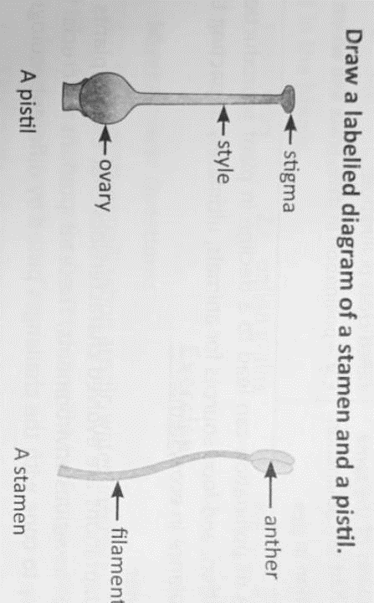4. The female reproductive part: ***Gynoecium***

E. Draw a labelled diagram of a stamen and a pistil.

Teacher Signature: Mrs. Rupa P Principal Signature