**Veda International School**

**Kusugal Road, Hubballi Ph: 0836-2002275**

(ICSE Board)

WORKSHEET

**Name: _____________________________ Subject: English - 2 Date: _____________**

**Roll No : __________________ Grade : II**

**Teacher Sign : _____________ Total Marks: 10 M**

**1.Match the following picture on left with the one on the right side name the two :**

**2 marks**

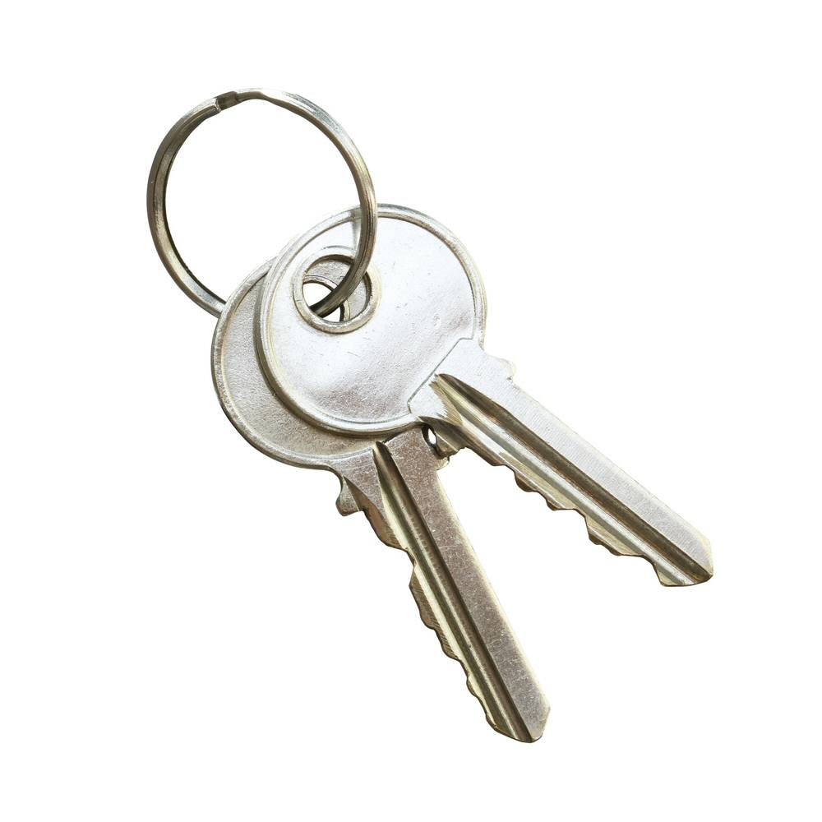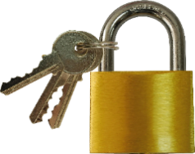

1. Lock keys ______________

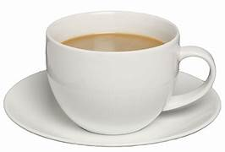

1. Cup Moon ______________

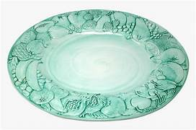

1. Sun Saucer ______________

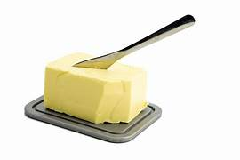

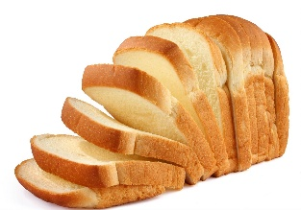

1. Bread Butter ______________

**2.Fill in the blanks with correct articles : A An 4 marks**

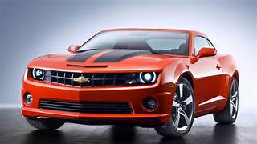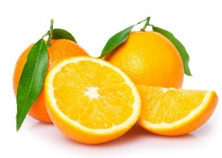

**______ orange ____ Car**

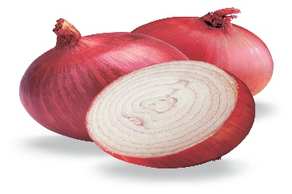

**____ Ship ____ Onion**

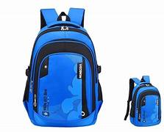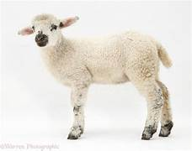

**____ Bag ____ Lamb**

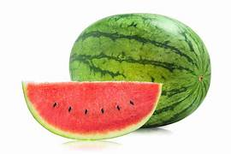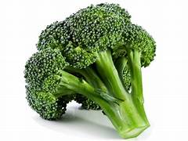

**____ Broccoli ____ Watermelon**

**_____ Broccoli ____ Watermelon**

1. **Think of some proper nouns for each common noun : 4 marks**

|  |  |  |
| --- | --- | --- |
|  | **Common Noun** | **Proper Noun** |
|  | **Horse** |  |
|  | **Food** |  |
|  | **Alarm** |  |
|  | **Rabbit** |  |