Project. Maths

Note –

1. Every project should be done on chart paper not on project paper. (If there is given any working model so working model should be in bigger size.)
2. It is compulsory to all each subject projects have 10 marks.
3. Project topics will be given to each child according to roll no.
4. Project submission till date (10 / 10/24)
5. Write the roll no, class, division of child on backside of each chart paper on left corner in small handwriting not in bold.
6. Use the different colour makers pens for making boards.

**Roll number 1 to 7**

Project name:- place value working model of 3 digit number . Students can make one ,tens and hundreds place value model. For more information images given below.

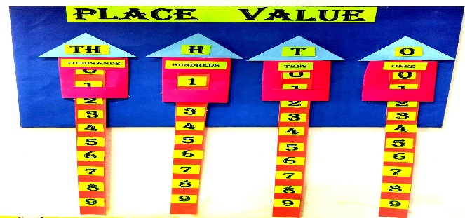

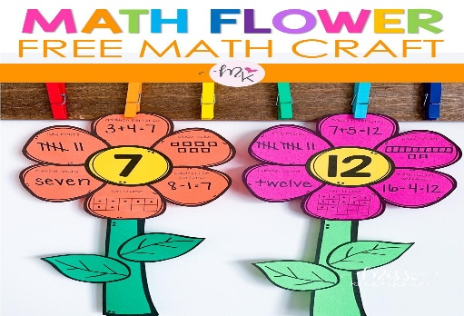**Roll number 8 to 16**

Project name: maths flowers, go through by the image.

**Roll number 9 to 25**

Project name :-before and after number working model (3 digit numbers.

11 to 20-working model multiplication flower.

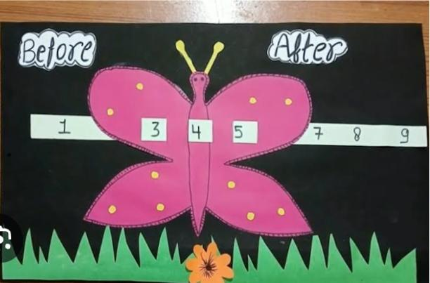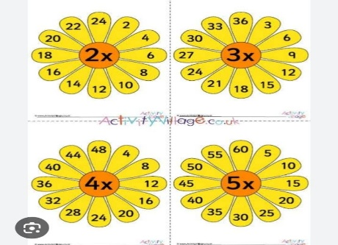Both projects should be in bigger size. For the more details images are given below.

**Roll number** 26 to 30

Project name:-11 to 20 multiplication tables, on big chart with big handwriting.

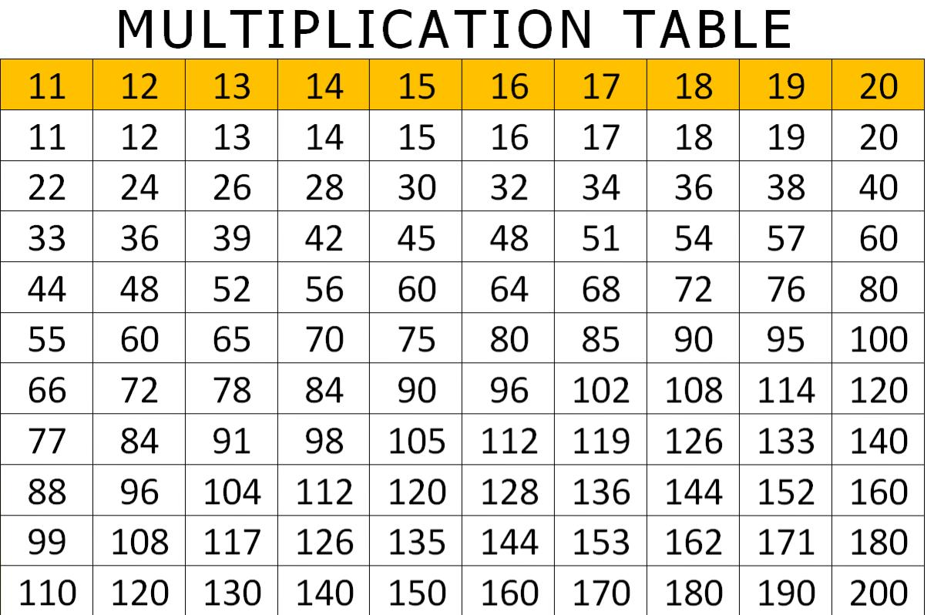

**Roll number 30 to 33**

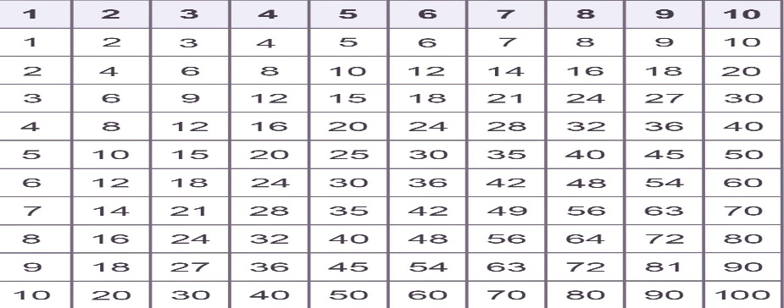**Project name:-1 to 10 multiplication table on big chart with begin writing.**