## **Federalism**

**MCQs**

1. Which among the following are examples of ‘Coming together federations’?  
(a) India, Spain and Belgium  
(b) India, USA and Spain  
**(c) USA, Switzerland and Australia**  
(d) Belgium and Sri Lanka

2. The Union List includes subjects such as:  
(a) Education, forests, trade unions, marriages, adoption and succession.  
(b) Police, trade, commerce, agriculture and irrigation.  
(c) Residuary subjects like computer software.  
**(d) Defence, foreign affairs, banking, currency, communication**

3. The system of Panchayati Raj involves:  
(a) Village, State and Union levels  
(b) Village, District and State levels  
(c) Village and State levels  
**(d) Village, Block and District levels**

4. Which one of the following States in India has its own Constitution?  
(a) Uttarakhand  
(b) Madhya Pradesh  
**(c) Jammu & Kashmir**  
(d) Nagaland

5. Which of the following countries is an example of “coming together federation”?  
**(a) U.S.A**  
(b) India  
(c) Spain  
(d) Belgium

6. Here are three reactions to the language policy followed in India. Which of the following holds true in the case of India?  
**(a) The policy of accommodation has strengthened national unity.**(b) Language based states have divided us by making everyone conscious of their language.  
(c) The language policy has only helped to consolidate the dominance of English over all other languages.

7. Consider the following statements on the practice of federalism in India. Identify those which hold true for decentralisation after 1992.  
A. Local governments did not have any power or resources of their own.  
B. It became constitutionally mandatory to hold regular elections to local government bodies.  
C. The state governments are required to share some powers and revenue with local government bodies.  
D. No seats are reserved in the elected bodies for scheduled castes, scheduled tribes and other backward classes.  
**(a) B and C**  
(b) A and C  
(c) A and D  
(d) B and D

8. In a ‘Holding together federation’:  
A. A large country divides its power between constituent states and the national government.  
B. The Central government tends to be more powerful vis-a-vis the States.  
C. All the constituent states usually have equal powers.  
D. Constituent states have unequal powers.  
Which of the above statements are correct?  
(a) A, B, C and D  
(b) A and D  
(c) B and C  
**(d) A, B and D**

* **SHORT ANSWERS FOR 3 MARKS**

1. What other factors besides politics keep the federations united?  
Answer: Besides politics other factors that keep federations united are:

* Power sharing arrangements between the central and state governments
* Independent role of judiciary
* Language ethnicity
* Response to conflicting claims and
* Active participation of the people.

2. Explain the vertical division of power giving example from India. (2016)  
**Answer:** The power shared among the different levels of the government is known as the vertical distribution of power. It involves higher and lower levels of government. These levels are the Union government, the State government and the Local government. In India, the Union government is at the highest level. The government at the provincial or regional level is the State government. The Indian Constitution has further laid down the provision of distribution of power. This division of power is further extended to the levels of the government lower than the state governments. They are also called Municipal Corporations and the Municipalities in urban areas and Panchayati Raj in rural areas.  
Each level of the government exercises its power. There is no specification of the system of checks and balances. Each level has its own powers and areas of jurisdiction and no level can interfere in each other’s functioning. Such an arrangement ensures deepening of democracy.

3. Compare the federations of coming together type and holding together type? OR

Distinguish between coming together and holding together type of federations.   
**Answer:  
The following are the differences between coming together type and holding together federations.**

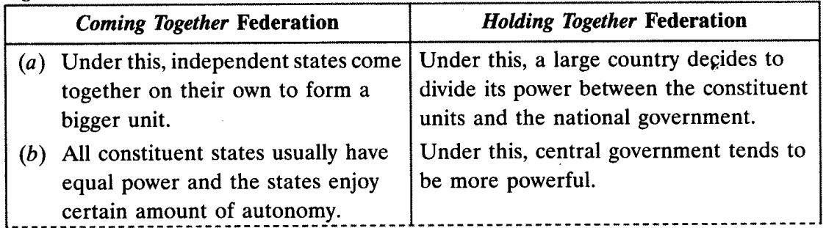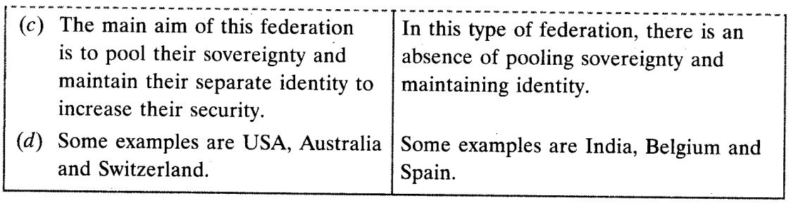

4. Explain five changes towards decentralization brought in the Constitution after the amendments made in 1992.   
Answer:The following steps were taken towards decentralization after 1992.

* It was made constitutionally mandatory to hold regular elections to local government bodies.
* Seats were reserved for Scheduled Castes (SCs), Scheduled Tribes (STs) and Other Backward communities (OBCs) in the elected bodies.
* Women were given one-third representation.
* An independent institution, called state election commission, was created to conduct local body elections.
* State governments were required to share this power and revenue with local bodies.

5. Explain the threefold distribution of legislative powers between the Union Government and the State Governments.  
Answer: Legislative powers are divided between the Union government and the State Governments by the Constitution of India. The Constitution is the supreme power in the country and the legislative powers are divided into various areas of government jurisdiction into three lists.  
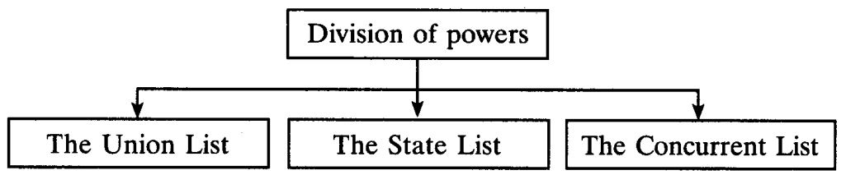

* **The Union List:** The Union List is given in Seventh Schedule in the Constitution of India on which Parliament has exclusive power to legislate. It contains areas like defence, foreign affairs, currency and communications.
* **The State List:** The State List is also in the Seventh Schedule of the constitution containing subjects like social service, police and Health, which are under the jurisdiction of the state government. Only state legislature can pass laws on these subjects.
* **The Concurrent List:** The Concurrent List contains items like criminal law, forests, population control in which both parliament and state legislature can pass laws. However, in case of any conflict arising between the laws made by the parliament and the laws made by the state legislature, the laws made by the parliament will prevail.

6. Explain the vertical division of power by giving examples from India.   
Answer: When power is shared among governments at different levels, i.e., the Union or the Central Government, the State Government and the Municipality and Panchayat at the lower level. This division of power involving higher and lower levels of government is called the vertical division of power.  
Vertical division of power in India: The Constitution declares India as a Union of States. Although the word ‘Federation’ is not used, the Indian Union is based on the principles of federation. The Constitution originally provided for a two-tier system of government, the Union Government or the Central Government representing Union of India and the State Governments.A third-tier of federation was added in the form of Panchayats and Municipalities. As in any federation, these different tiers enjoy separate jurisdiction. The Constitution provides for a three-fold distribution of legislative powers between the Union Government and State Government. It contains three lists:

1. Union List (97 Subjects)
2. State List (66 Subjects)
3. Concurrent List (47 Subjects)

7. Why is decentralisation favoured in democracy? Identify any two reasons.   
Answer: Five advantages of decentralisation of power:

1. When power is taken away from Central and State Governments and given to local governments, it is called decentralisation. The basic idea behind decentralisation is that there are a large number of problems and issues which are best settled at the local level. People have better knowledge of problems in their localities.
2. They also have better ideas on where to spend money and how to manage things more efficiently.
3. Besides, at the local level, it is possible for the people to directly participate in decision making. This helps to inculcate a habit of democratic participation.
4. Local government is the best way to realise one important principle of democracy, namely local self¬government.
5. The need for decentralisation was recognised in our Constitution. A major step towards decentralisation was taken in 1992. The Constitution was amended to make the third tier of democracy more powerful and effective.

8. India comes under which type of federation and why?   
Answer:- India comes under ‘a holding together’ type federation. In this type of federation, a large country divides its power between the constituent States and the National government. There is one government for the entire country and the others are governments at the State level. Both Central and State Governments enjoy their power independent of the other.

The Central government tends to be more powerful vis-a-vis the states. Often different constituent units of the federation have unequal powers. For example, special powers have been granted to Jammu & Kashmir.

9.State two agreements through which federations have been formed. Give an example of each.   
Answer: (i) ‘Coming together’ federations—This agreement induces independent states coming together on their own to form a bigger unit, so that by pooling sovereignty and retaining identity they can increase their security.  
Examples are: USA, Switzerland and Australia. All the constituent states have equal power and are strong vis-a-vis the federal government.

(ii) ‘Holding together’ federations — In this agreement, a large country decides to divide its power between the constituent States and the national government. The Central Governments tend to be more powerful vis-a-vis the states. Often different constituent units of the federation have unequal powers. Some units are granted special powers, for example, India granted special powers to Jammu & Kashmir.  
Other examples are Spain and Belgium.

* **LONG ANSWERS FOR MARKS 5**

1. Explain democratic policies adopted by Government of India which made it a successful federation.  
Answer: The following democratic policies have helped India to be a successful federation.

* The powers of the central and state governments have been clearly seperated under the Union, State and Concurrent Lists. It removes the possibility of any type of interference in the functioning of the central and state governments.
* A three-tier system of governance has been approved under the Union, State and Local governments. They govern the people at their respective levels.
* Some states like Jammu and Kashmir and Arunachal Pradesh have been given special status so as to maintain their autonomy.
* The fundamental structure of the Indian Constitution cannot be unilateraly changed by the Parliament. Any amendment in the Constitution needs the approval of both the houses of the Parliament and at least half of the total states.
* The sources of income of different levels of the government has been clearly stated in the Constitution to avoid any conflict.

2. How are the legislative powers divided between the Union government and the State Governments?  
Answer: The legislative powers are divided between the Union Government and the State Governments by the Constitution of India. The constitution is supreme in the country and the legislative powers are divided into various areas of government jurisdiction into three lists—Union List, State List, Concurrent List.

* **The Union List:** Union List includes subjects like defence, foreign affairs, banking, currency and communications. The Union Government alone can make laws relating to these subjects.
* **The State List:** State list contains subjects like police, trade, commerce, agriculture and irrigation, which come under the jurisdiction of the State Governments. Only the State Legislatures can make laws on these subjects.
* **The Concurrent list:** The Concurrent list contains items like education, forest, trade unions, marriage, adoption and succession, which are of common interest to both the Union government and the State Governments. Both can make laws on these subjects. However, in case of any conflict, the law made by the Union Government will prevail.

3. Which five provisions of Indian Constitution make India a full-fledged federation?  
Answer: A federation is a country in which the powers are divided between the union and its constituents. India is an example of holding together federation, where the country decides to create constituent units, thereby dividing the powers and duties between the centre and the states.  
The following are the five provisions that make India a full-fledged federation.

* **Two or more levels of government:** We have a federal system whereby the constitution has more than two tiers of the government, viz. the Union  
  Government, State Governments and Local Government. This implies that there are more than two levels of government administration among which powers are divided and duties are given.
* **Three Lists:** The powers are divided between the Centre and the States by three Lists: Union list, State List and Concurrent list.  
  Union List deals with the issues relating to the Centre, State List deals with the issues relating to the States and Concurrent List deals with the matters of both the Centre and the States.
* **Rigid Constitution:** The Government of India is governed by the Constitution of India and it is considered the Supreme Power in the Country. It is not an easy task to amend the constitution. For a constitutional provision to be amended, it requires ratification by half of the State Legislatures, failing which the Constitution cannot be amended.
* **Bicameral Legislature:** India has a bicameral legislature which means that the Parliament consists of two houses, viz, the Lok Sabha and the Rajya Sabha. One represents the country and the other represents the interest of the constituent states.
* **Financial Autonomy:** The revenue sources of both the Centre and States have been clearly defined, that ensures financial autonomy to both the Centre and the States. In layman’s language, the Centre and the State have different sources of income, which means they are independent of each other when it comes to revenue.
* **Independent Judiciary:** Independent judiciary is the essence of federal government. Here, courts have the power to interpret the constitution and the powers of the different levels of government. In India, the highest court—the Supreme Court—acts as an umpire if a dispute arises between the different levels of government in the exercise of their respective powers.

4. What is federalism? Distinguish between the federations of come together type and hold together type. Mention two countries each for both the types of federations.   
**Answer:** Federalism is a system of government in which the power is divided between a central authority and various constituent units of the country. Both these levels of the government—the central and the state—enjoy their power independent of the other.  
The following are the differences between coming together type and holding together federations.

  


5. How has federalism succeeded in India? What policies adopted by India have ensured this success? OR

Explain any four features of federalism.  
Answer:  
A federation is a country in which the powers are divided between the union and its constituents. India is an example of holding together federation, where the country decides to create constituent units, thereby dividing the powers and duties between the centre and the states.  
The following are the five provisions that make India a full-fledged federation.

* **Two or more levels of government:** We have a federal system whereby the constitution has more than two tiers of the government, viz. the Union  
  Government, State Governments and Local Government. This implies that there are more than two levels of government administration among which powers are divided and duties are given.
* **Three Lists:** The powers are divided between the Centre and the States by three Lists: Union list, State List and Concurrent list.  
  Union List deals with the issues relating to the Centre, State List deals with the issues relating to the States and Concurrent List deals with the matters of both the Centre and the States.
* **Rigid Constitution:** The Government of India is governed by the Constitution of India and it is considered the Supreme Power in the Country. It is not an easy task to amend the constitution. For a constitutional provision to be amended, it requires ratification by half of the State Legislatures, failing which the Constitution cannot be amended.
* **Bicameral Legislature:** India has a bicameral legislature which means that the Parliament consists of two houses, viz, the Lok Sabha and the Rajya Sabha. One represents the country and the other represents the interest of the constituent states.
* **Financial Autonomy:** The revenue sources of both the Centre and States have been clearly defined, that ensures financial autonomy to both the Centre and the States. In layman’s language, the Centre and the State have different sources of income, which means they are independent of each other when it comes to revenue.
* **Independent Judiciary:** Independent judiciary is the essence of federal government. Here, courts have the power to interpret the constitution and the powers of the different levels of government. In India, the highest court—the Supreme Court—acts as an umpire if a dispute arises between the different levels of government in the exercise of their respective powers.

6. The creation of linguistic states was the first and the major test of democratic politics in our country. Justify the statement.  
Answer: The creation of linguistic states was the first and the major test of democratic politics in our country.

* After 1947, the boundaries of several old states of India were proposed to be changed to ensure that people who spoke the same language lived in the same state. It was felt that it would case administrative constraints also.
* Some states like Nagaland were not created on the basis of language but because of their distinct culture, ethnicity and geography.
* When the demand for the formation of linguistic states rose, some leaders feared that it would again lead to disintegration.
* This idea was thus resisted for some time fearing any further tension or conflict within the country.
* But when the actual creation of states was done on the basis of language, it so proved that the country was more united. This process did away with all fears and tension.
* Thus, the framing of the language policy was the test for Indian federation. It inspired the confidence in different language speaking people that no language will be imposed on them. In a way Language policy has strengthened the unity and integrity of India.

7. Which five provisions of the constitutional amendment of 1992 really strengthened the third tier of democracy in India? Explain.  
Answer: Major steps towards decentralisation and strengthening of third tier taken in 1992 were:

1. Now it is constitutionally mandatory to hold regular elections to Local Government bodies.
2. Seats are reserved in elected bodies for scheduled castes, scheduled tribes and other backward classes (OBCs).
3. Atleast one-third of all positions and seats are reserved for women.
4. An independent institution called the State Election Commission was created to conduct Panchayat and Municipal elections.
5. The State Governments are required to share some powers and revenue with Local Government bodies.

8. Why has federalism succeeded in India? Which are the policies adopted by India that have ensured it? Explain.   
Answer:  
Reasons for success of federalism in India are:

1. Clearly laid out Constitutional Provisions providing a three-fold distribution of powers in the three lists—Union List, State List and Concurrent List—between the Union Government and State Governments.
2. The nature of democratic politics in our country which ensures that the spirit of federalism, respect for diversity and desire for living together became a shared ideal.
3. The creation of linguistic states. Boundaries of several old states of India were changed in order to create new states. This was done to ensure that people who spoke the same language lived in the same state. Later some states were created to recognise differences based on culture, ethnicity or geography.  
   For example: Nagaland, Uttrakhand, Jharkhand, Telangana, etc.
4. Restricting Centre-State relations. The constitutional arrangements for sharing power work depending on how the ruling parties and leaders follow these arrangements. For a long time, the same party ruled both at the Centre and in most of states. Post-1990 saw the rise of regional parties. Since no single party got a clear majority in the Lok Sabha, the national parties had to enter into an alliance which led to a new culture of power sharing and respect for autonomy of State Governments.

9. Explain any five features of federalism.   
Answer:-- Features of federalism:

1. There are two or more levels of government.
2. Different levels of government govern the same citizens, where each level has its own jurisdiction in specific matters of legislation, taxation and administration.
3. Existence and authority of each level of government is constitutionally governed.
4. The fundamental provisions of the Constitution cannot be unilaterally changed. Such changes require the consent of both the levels of government.
5. Courts have the power to interpret the Constitution and powers of the different levels of government. The highest court acts as the umpire if any dispute arises between different levels of governments.
6. Sources of revenue for each level of government are specified to ensure its financial autonomy.
7. Federal system has dual objectives. To safeguard and promote unity of the country, and to accommodate regional diversity.

10. Describe the three forms of power sharing among different organs of government in India.   
Answer:-- The Constitution declared India as a Union of States based on the principles of federalism. The Constitution originally provided for a two-tier system of government, the Union or the Central Government representing Union of India and the State Governments. Later, a third tier was added in the form of Panchayats and Municipalities.

As in any federation, these different tiers enjoyed separate jurisdiction. The Constitution provided a three-fold distribution of legislative powers:

1. Union List includes subjects of national importance, i.e., defence of the country, foreign affairs, banking, communications and currency.
2. State List contains subjects of state and local importance, i.e., police, trade, commerce, agriculture and irrigation.
3. Concurrent List includes subjects of common interest to both the Union Government as well as the State Governments, i.e., education, forests, trade unions, marriages, adoption and succession.  
   In case of dispute, law made by the Union Government shall prevail.
4. Residuary—Subjects which do not fall in any of the three lists, i.e., computer software, etc. Union Government has the power to legislate such subjects.
   * As India is an example of ‘holding together’ federation, all states in the Indian Union do not have identical powers. Some states enjoy special status such as Jammu & Kashmir. There are some states too small to become independent like the Union Territories of Chandigarh and Lakshadweep.
   * This sharing of power between the Union Government and State Governments is basic to the structure of the Constitution. Any change to it, has to be passed by both the Houses of the Parliament with at least two-third majority.
   * The judiciary plays an important role in the implementation of constitutional procedures. In case of any dispute about division of powers, the High Courts and the Supreme Court make a decision.

12. Describe in brief the language policy of India?  
Answer:

1. Our Constitution did not give the status of national language to any one language.
2. The formation of linguistic states united the country and made administration easier.
3. The leaders of our country adopted a very cautious attitude in spreading the use of Hindi. Hindi was identified as official language.
4. The banning of use of English for official purposes in 1965 took a violent form in Tamil Nadu. The Central Government responded by agreeing to continue the use of English along with Hindi for official purposes.
5. Promotion of Hindi is an official policy of the Government of India but it does not impose Hindi on states where people speak a different language.
6. Besides Hindi, there are 21 other languages recognised as scheduled languages by the Constitution.
7. This flexibility shown by Indian leaders helped our country avoid the situation that Sri Lanka finds itself in.

13. What were the major steps taken to make decentralisation more effective? Or  
What amendments were made in the Constitution in order to make the third tier ofdemocracy (Local Government) more powerful and effective?  
Answer:  
Major steps towards decentralisation taken in 1992 are:

1. Now it is constitutionally mandatory to hold regular elections to Local Government bodies.
2. Seats are reserved in elected bodies for scheduled castes, scheduled tribes and other backward classes (OBCs).
3. Atleast one-third of all positions are reserved for women.
4. The State Election Commission was created to conduct Panchayat and Municipal elections.
5. The State Governments are required to share some powers and revenue with Local Government bodies.

14. Explain the structure of the new Panchayati Raj institutions, both in rural and urban areas.  
Answer:  
Rural Local Government is known by the name of Panachayati Raj/ Democratic decentralization.

* Each village or group of villages has a Gram Panchayat.
* Panch, President or Sarpanch are directly elected by all the adult population of the village and is the decision-making body.
* The Panchayat works under the supervision of Gram Sabha, with all the voters as its members.
* The local structure goes up to the district level—a group of Gram Panchayats form a Panchayat Samiti or Block or Mandal.
* All the Panchayat Samitis or Mandals together constitute the Zilla Parishad which consists of elected members.
* Lok Sabha members, Local MLAs and officers are also members of the Zilla Parishad.
* Its Chairperson is the political head of the Parishad.

Urban areas local bodies.

* Municipalities are set up in towns.
* Big cities are constituted into Municipal Corporations.
* Both are controlled by elected bodies consisting of people’s representatives.
* Municipal chairperson is the political head of the Municipality.  
  The head of Municipal Corporation is an officer called the Mayor.

15. How is federal power sharing more effective today than in the early years? Explain.  
Answer:

1. Federal power sharing is more effective because of the nature of democratic politics in India. It has ensured that the spirit of federalism, respect for diversity and desire for living together have become a shared ideal in our country.
2. Federal power sharing has helped to inculcate a habit of democratic participation. Federal power sharing is the best way to realise one important principle of democracy, namely local self-government. Constitutional status for local government has helped to deepen democracy.
   * It has increased women’s representation and voice in democracy.
   * Federal power sharing has led to formation of linguistic states which has actually made the country more united. It has also made administration easier.
   * It reduces the power of the Central government and gives power to regional governments.