

**June Art Syllabus 2023-24 Class-VIII**

**1. Foundation Drawing (Basic Steps)**

**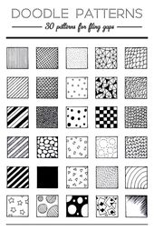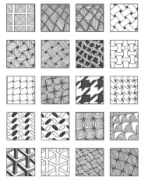**

**2. Traditional Art**

Traditional art is art that is part of a culture of a certain group of people, with skills and knowledge passed down through generations.

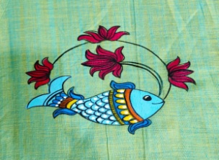

**Traditional Art Forms of India (Folk Art or Tribal Art)**

**\*** Madhubani Painting

\* Pattachitra Painting

\* Mysore Painting

\* Tanjore Painting

\* Rajput Painting

\* Warli Painting

\* Gond Paainting

\* Bhil Painting

\* Mural Painting etc.

**July**

**3.Design**

An outline, sketch, or plan, as of the form and structure of a work of art, organization or structure of formal elements in a work of art; composition.

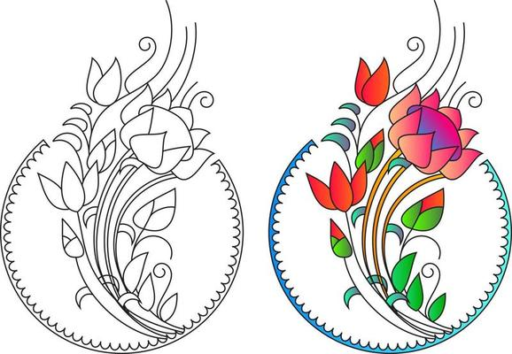

**4. Gond Painting**

It is a form of painting from folk and tribal art that is practiced by one of the largest tribes in India – the Gond – who are predominantly from Madhya Pradesh, but can also be found in pockets of Andhra Pradesh, Maharashtra, Chhattisgarh, and Odisha.

Jangarh Singh Syam

While traveling in village Pattangarh, a group of such artists found a brilliant wall painting done by a young manual laborer aged seventeen called Jangarh Singh Syam, who later became a legendary name in the history of Gond painting.

**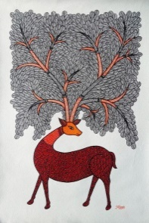**

**Some of the patterns used in Gond paintings are:**

* Dots.
* Fine Lines.
* Curved Lines.
* Dashes.
* Fish Scales.
* Drops of Water.
* Seed Shapes.
* Geometrical Shapes, etc.

**August**

**5. Memory drawing**

 Memory drawing is **the regular practice of training your visual memory to retain what you see**.

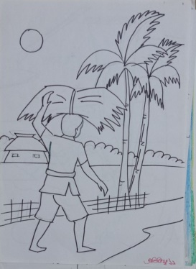

**6.Madhubani Painting**

Madhubani Art or Mithila Painting is a style of Indian painting, practiced in the Mithila region of BiharThis painting is done with variety of tools,including fingers,twigs,brushes,nib-pens and matchsticks and It is characterized by its eye-catching geometrical patterns. There is ritual content for particular occasions such as birth,marriage and festivals ,such as Holi,Kali puja, Upanayana, Durga puja etc. . Madhubani painting was traditionally created by the women of various communities in the Mithila region of Bihar.

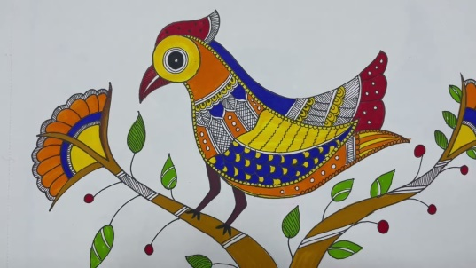

**September**

**Revision of Term I**

.**October**

**8.Mural Art**

The history of Indian mural painting starts in ancient and early medieval times, from the 2nd century BC to 8th – 10th century AD. There are more than 20 locations around India containing murals from this period, mainly natural caves and rock-cut chambers.The mural art is believed to have originated during the palaeolithic age; these paintings were painted on the stones in caves, tombs, or ceilings. In India, many mural paintings were dated to the 14th century and were found in Kerala.

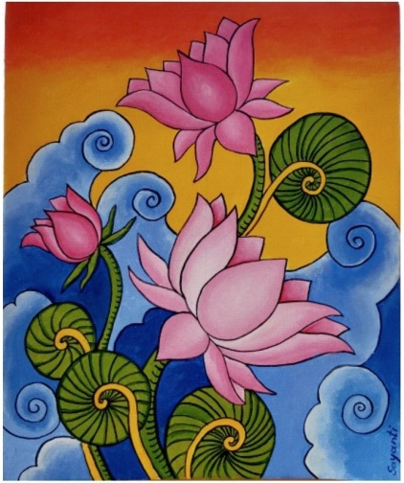

**9.Warli painting**

**Warli painting** is of [tribal art](https://en.wikipedia.org/wiki/Tribal_art) mostly created by the tribal people from the North [Sahyadri Range](https://en.wikipedia.org/wiki/Western_Ghats" \o "Western Ghats) in Maharashtra, India.The Warli painting tradition in [Maharashtra](https://en.wikipedia.org/wiki/Maharashtra) are among the finest examples of the folk style of paintings. The [Warli](https://en.wikipedia.org/wiki/Warli" \o "Warli) tribe is one of the largest in India, located outside Mumbai . Till the 1970s, even though the tribal style of art is thought to date back as early as 10th century A.D.[[1]](https://en.wikipedia.org/wiki/Warli_painting" \l "cite_note-1) The Warli culture is centered on the concept of [Mother Nature](https://en.wikipedia.org/wiki/Mother_Nature) and elements of nature are often focal points depicted in Warli painting. Farming is their main way of life and a large source of food for the tribe. They greatly respect nature and wildlife for the resources that they provide for life.[[2]](https://en.wikipedia.org/wiki/Warli_painting#cite_note-2) Warli artists use their clay huts as the backdrop for their paintings, similar to how ancient people used [cave walls](https://en.wikipedia.org/wiki/Cave_paintings_in_India) as their canvases.

[Jivya Soma Mashe](https://en.wikipedia.org/wiki/Jivya_Soma_Mashe), the artist in Thane district has played a great role in making the Warli paintings more popular.

**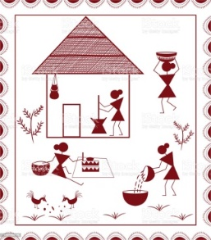** **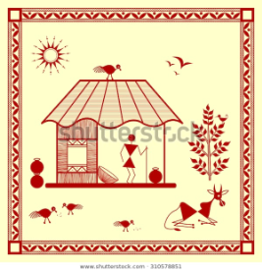**

**November**

**10.Rajasthani painting**

Rājasthānī painting, the style of miniature painting that developed mainly in the independent Hindu states of Rājasthān in western India in the 16th–19th century. It evolved from Western Indian manuscript illustrations, though Mughal influence became evident in the later years of its development. there are three kinds of Rajasthani paintings, Phad, Pichwai and Miniature. Phad and Pichwai are done on cloth, while miniature is done on specially treated paper in vegetable dyes. Phad, a scroll painting done on long cloth panels depicts folk and historic stories in a narrative style.

**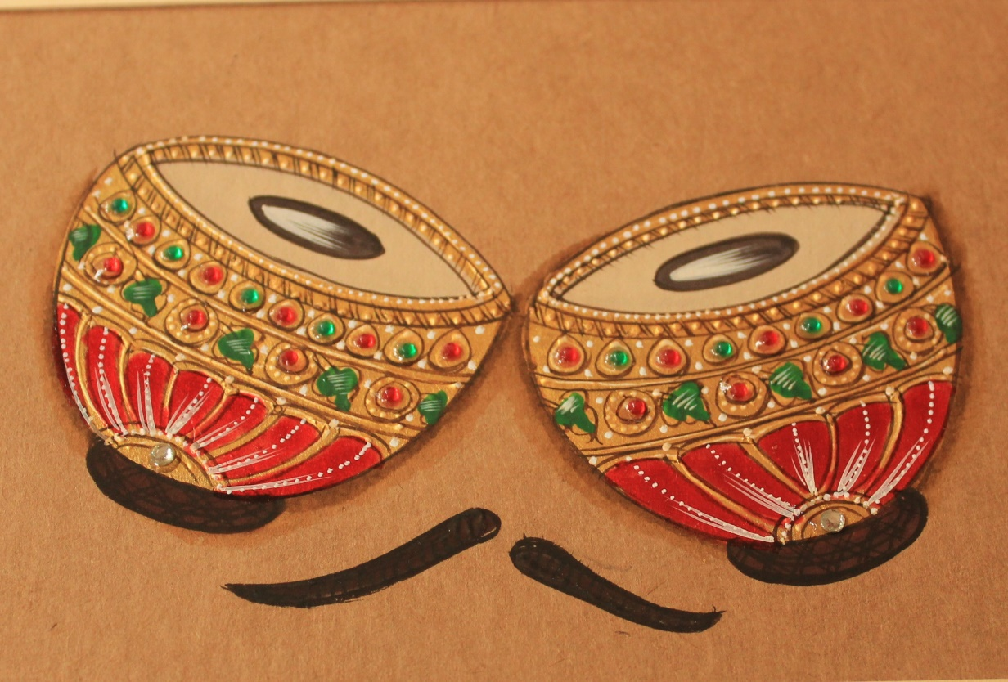**

**December**

**Annual day preparation**

**January**

**11.Pen Drawing**

Artwork executed wholly or in part with pen and ink, usually on paper. Pen drawing is fundamentally a linear method of making images.

**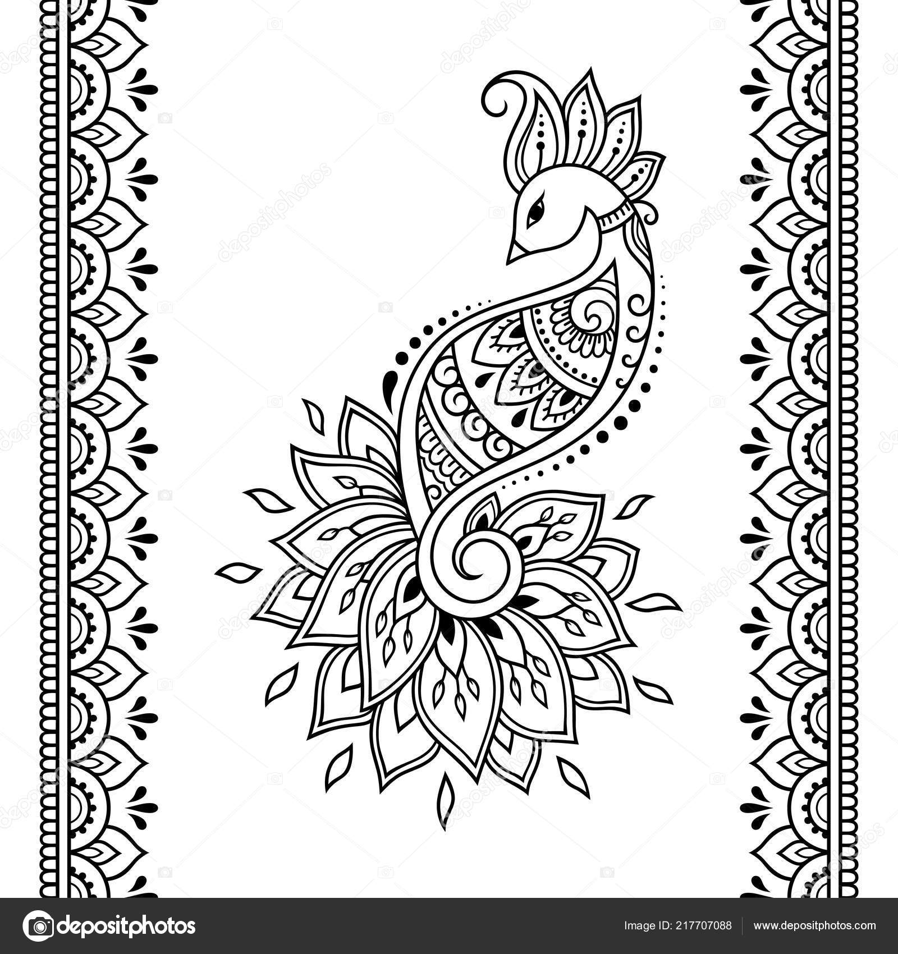**

**12.Object drawing (Lamp)**

Object drawing or still life as an art form came into its own in the 16thC and 17thC. A.D. Prior to that time the subject matter was studied primarily as preparation for use in figurative composition. The subject matters found in object drawing are natural and man made objects of almost any shape and function

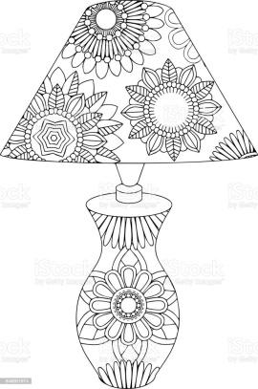

**February**

**13. Still life**

A still life is a **drawing or painting that focuses on still objects**. The subject matter is inanimate and never moves, typically with a focus on household

**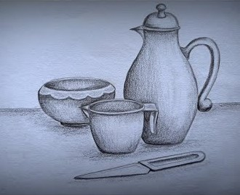**

**5. Memory drawing**

 Memory drawing is **the regular practice of training your visual memory to retain what you see**.

**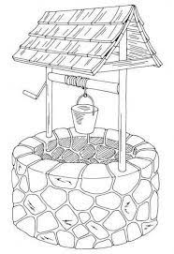**

**March**

**Revision of Term I**



**June Art Syllabus 2023-24 Class-IX**

**1.Madhubani Painting**

Madhubani Art or Mithila Painting is a style of Indian painting, practiced in the Mithila region of BiharThis painting is done with variety of tools,including fingers,twigs,brushes,nib-pens and matchsticks and It is characterized by its eye-catching geometrical patterns. There is ritual content for particular occasions such as birth,marriage and festivals ,such as Holi,Kali puja, Upanayana, Durga puja etc. . Madhubani painting was traditionally created by the women of various communities in the Mithila region of Bihar.

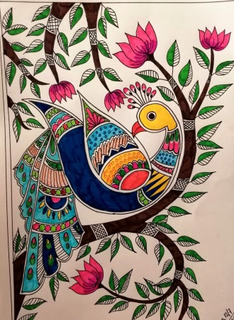

**2.Object Drawing (Vase)-**Object drawing or still life as an art form came into its own in the 16thC and 17thC. A.D. Prior to that time the subject matter was studied primarily as preparation for use in figurative composition. The subject matters found in object drawing are natural and man made objects of almost any shape and function

**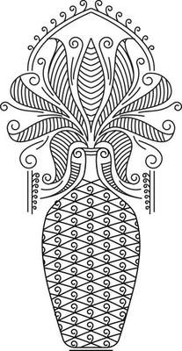**

**July**

**3. Gond Painting**

It is a form of painting from folk and tribal art that is practiced by one of the largest tribes in India – the Gond – who are predominantly from Madhya Pradesh, but can also be found in pockets of Andhra Pradesh, Maharashtra, Chhattisgarh, and Odisha.

Jangarh Singh Syam

While traveling in village Pattangarh, a group of such artists found a brilliant wall painting done by a young manual laborer aged seventeen called Jangarh Singh Syam, who later became a legendary name in the history of Gond painting.

**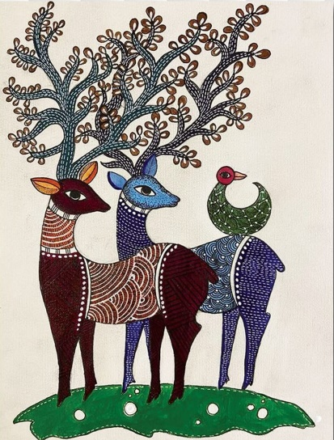**

**4. Memory drawing**

 Memory drawing is **the regular practice of training your visual memory to retain what you see**.

**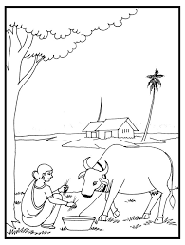**

**August**

**5.Pen drawing**

Artwork executed wholly or in part with pen and ink, usually on paper. Pen drawing is fundamentally a linear method of making images.

**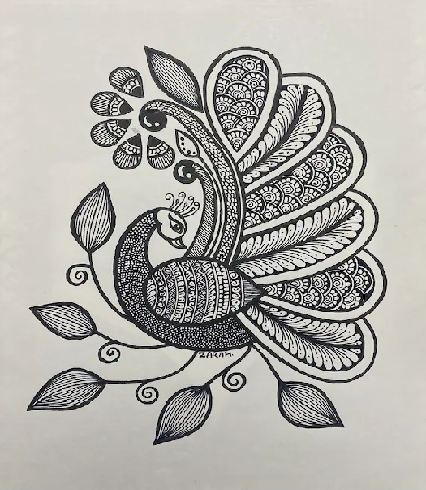**

**6. Still life**

A still life is a **drawing or painting that focuses on still objects**. The subject matter is inanimate and never moves, typically with a focus on household.

**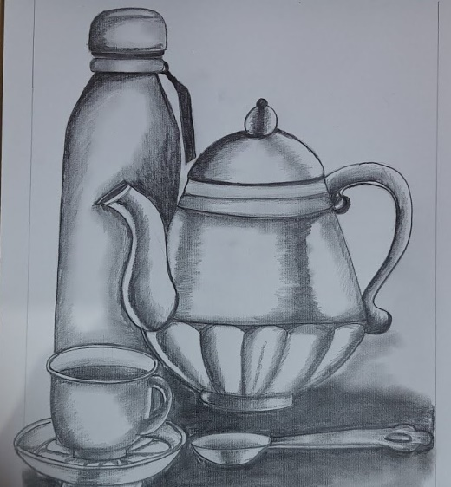**

**September**

**Revision of Term I**

**October**

**7.Mural Art**

The history of Indian mural painting starts in ancient and early medieval times, from the 2nd century BC to 8th – 10th century AD. There are more than 20 locations around India containing murals from this period, mainly natural caves and rock-cut chambers.The mural art is believed to have originated during the palaeolithic age; these paintings were painted on the stones in caves, tombs, or ceilings. In India, many mural paintings were dated to the 14th century and were found in Kerala.

**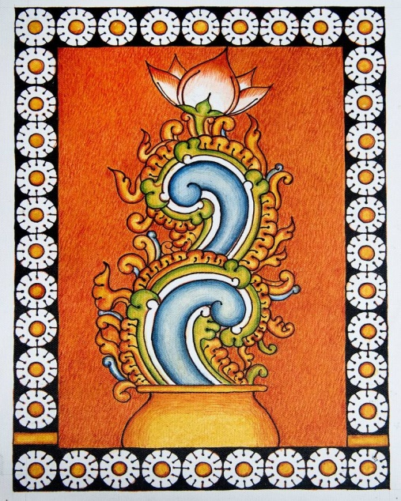**

**8. 11.Design**

An outline, sketch, or plan, as of the form and structure of a work of art, organization or structure of formal elements in a work of art; composition.

**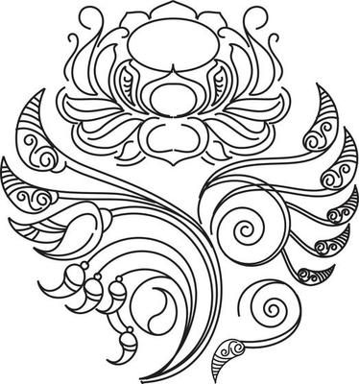**

**November**

**9. Traditional Art**

Traditional art is art that is part of a culture of a certain group of people, with skills and knowledge passed down through generations.

**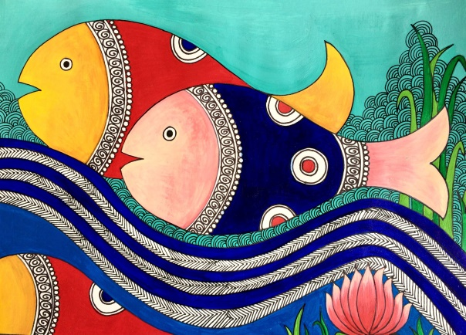**

**9.Warli painting**

**Warli painting** is of [tribal art](https://en.wikipedia.org/wiki/Tribal_art) mostly created by the tribal people from the North [Sahyadri Range](https://en.wikipedia.org/wiki/Western_Ghats" \o "Western Ghats) in Maharashtra, India.The Warli painting tradition in [Maharashtra](https://en.wikipedia.org/wiki/Maharashtra) are among the finest examples of the folk style of paintings. The [Warli](https://en.wikipedia.org/wiki/Warli" \o "Warli) tribe is one of the largest in India, located outside Mumbai . Till the 1970s, even though the tribal style of art is thought to date back as early as 10th century A.D.[[1]](https://en.wikipedia.org/wiki/Warli_painting" \l "cite_note-1) The Warli culture is centered on the concept of [Mother Nature](https://en.wikipedia.org/wiki/Mother_Nature) and elements of nature are often focal points depicted in Warli painting. Farming is their main way of life and a large source of food for the tribe. They greatly respect nature and wildlife for the resources that they provide for life.[[2]](https://en.wikipedia.org/wiki/Warli_painting#cite_note-2) Warli artists use their clay huts as the backdrop for their paintings, similar to how ancient people used [cave walls](https://en.wikipedia.org/wiki/Cave_paintings_in_India) as their canvases.

[Jivya Soma Mashe](https://en.wikipedia.org/wiki/Jivya_Soma_Mashe), the artist in Thane district has played a great role in making the Warli paintings more popular.

**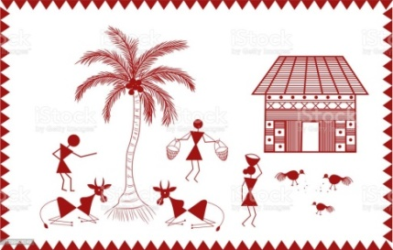**

**December**

**Annual day preparation**

**January**

**10.Memory Drawing**

 Memory drawing is **the regular practice of training your visual memory to retain what you see**.

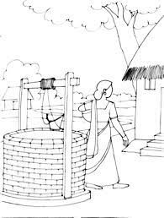

**11.Gond Art**

It is a form of painting from folk and tribal art that is practiced by one of the largest tribes in India – the Gond – who are predominantly from Madhya Pradesh, but can also be found in pockets of Andhra Pradesh, Maharashtra, Chhattisgarh, and Odisha.

Jangarh Singh Syam

While traveling in village Pattangarh, a group of such artists found a brilliant wall painting done by a young manual laborer aged seventeen called Jangarh Singh Syam, who later became a legendary name in the history of Gond painting.

**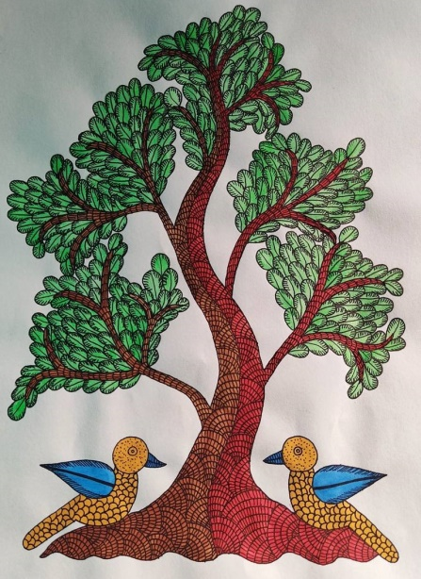**

**February**

**12.Rajasthani painting (Miniature Painting )**Rājasthānī painting, the style of miniature painting that developed mainly in the independent Hindu states of Rājasthān in western India in the 16th–19th century. It evolved from Western Indian manuscript illustrations, though Mughal influence became evident in the later years of its development. there are three kinds of Rajasthani paintings, Phad, Pichwai and Miniature. Phad and Pichwai are done on cloth, while miniature is done on specially treated paper in vegetable dyes. Phad, a scroll painting done on long cloth panels depicts folk and historic stories in a narrative style

**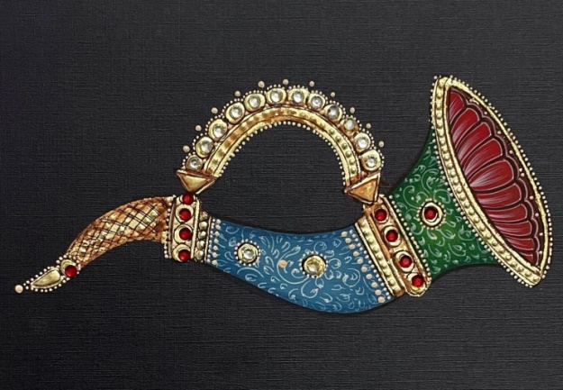**

**13.Aipan Art-**Aipan art originated from Almora in Uttarakhand, which was founded during the reign of the Chand dynasty. It flourished during the reign of the Chand dynasty in the Kumaon region. The designs and motifs are motivated by the beliefs of the community and various aspects from nature.

Aipan is taken from the **word Lepana from Sanskrit, which means plaster**. Aipan art is similar in different areas of India.

**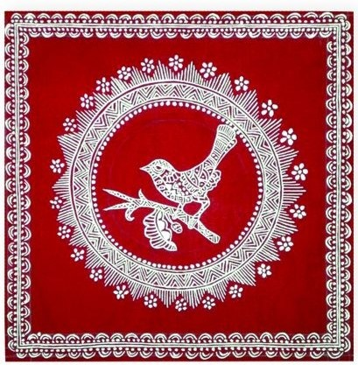**

**March**

**Revision of Term II**

**November**

|  |  |  |
| --- | --- | --- |
| 1 | Balloons | Object Drawing |
| 2 | Pomegranate | Nature Drawing |
| 3 | Bag, Lock | Object Drawing |

**December**

|  |  |  |
| --- | --- | --- |
| 1 | Kite | Object Drawing |
| 2 | Teapot | Object Drawing |
| 3 | Top | Object Drawing |

**January**

|  |  |  |
| --- | --- | --- |
| 1 | Caterpillar | Nature Drawing |
| 2 | Net | Object Drawing |
| 3 | House | Object Drawing |

**February**

|  |  |  |
| --- | --- | --- |
| 1 | Caterpillar | Nature Drawing |
| 2 | Net | Object Drawing |
| 3 | House | Object Drawing |

**Art Teacher Principal**

**June Art Syllabus 2023-24 Class-II**

|  |  |  |
| --- | --- | --- |
| 1 | Lamp | Object Drawing |
| 2 | Leaves | Nature Drawing |
| 3 | Leaves | Nature Drawing |

**July**

|  |  |  |
| --- | --- | --- |
| 1 | Refrigerator | Object Drawing |
| 2 | Tree | Nature Drawing |
| 3 | Ice Cream | Object Drawing |

**August**

|  |  |  |
| --- | --- | --- |
| 1 | Carrot | Object Drawing |
| 2 | Bottle Gourd | Nature Drawing |
| 3 | Book | Object Drawing |

**September**

|  |  |  |
| --- | --- | --- |
| 1 | Watermelon | Nature Drawing |
| 2 | Camera | Object Drawing |
| 3 | Lollipop | Object Drawing |

**October**

|  |  |  |
| --- | --- | --- |
| 1 | Cashew Fruit | Nature Drawing |
| 2 | Diya | Object Drawing |
| 3 | Flower | Nature Drawing |

**November**

|  |  |  |
| --- | --- | --- |
| 1 | Truck | Object Drawing |
| 2 | Glass | Object Drawing |
| 3 | Custard Apple | Nature Drawing |

**December**

|  |  |  |
| --- | --- | --- |
| 1 | Vase | Object Drawing |
| 2 | Bird | Memory Drawing |
| 3 | Flower | Nature Drawing |

**January**

|  |  |  |
| --- | --- | --- |
| 1 | Spectacles | Object Drawing |
| 2 | Geometrical Design | Object Drawing |
| 3 |  |  |

**February**

|  |  |  |
| --- | --- | --- |
| 1 | Design | Drawing |
| 2 | Landscape | Nature Drawing |
| 3 |  |  |

**Art Teacher Principal** **June Art Syllabus 2023-24**

|  |  |  |
| --- | --- | --- |
| 1 | Butterfly | Nature Drawing |
| 2 | Cake | Object Drawing |
| 3 | Teapot | Object Drawing |

**July**

|  |  |  |
| --- | --- | --- |
| 1 | Table Lamp | Object Drawing |
| 2 | Yatch | Object Drawing |
| 3 | Snail | Nature Drawing |

**August**

|  |  |  |
| --- | --- | --- |
| 1 | Coconut Tree | Nature Drawing |
| 2 | Mixer | Object Drawing |
| 3 | Flower | Object Drawing |

**September**

|  |  |  |
| --- | --- | --- |
| 1 | Flower Pot | Nature Drawing |
| 2 | Cup-Saucer | Object Drawing |
| 3 | Iron | Object Drawing |

**October**

|  |  |  |
| --- | --- | --- |
| 1 | Sun | Nature Drawing |
| 2 | Bird | Object Drawing |
| 3 | Still life Plant | Nature Drawing |

**November**

|  |  |  |
| --- | --- | --- |
| 1 | Hut | Object Drawing |
| 2 | Snake | Memory Drawing |
| 3 | Table | Object Drawing |

**December**

|  |  |  |
| --- | --- | --- |
| 1 | Chair, Center Table | Object Drawing |
| 2 | Well | Object Drawing |
| 3 |  |  |

**January**

|  |  |  |
| --- | --- | --- |
| 1 | Frog | Object Drawing |
| 2 | Design(Flower Leaves) | Nature Drawing |
| 3 |  |  |

**February**

|  |  |  |
| --- | --- | --- |
| 1 | Fish | Memory Drawing |
| 2 | Seascape | Nature Drawing |
| 3 | Design | Circle Design |

**Art Teacher Principal** **June Art Syllabus 2023-24 Class-IV**

|  |  |  |
| --- | --- | --- |
| 1 | Pot, Vase | Object Drawing |
| 2 | Teddy Bear | Object Drawing |
| 3 | Pot | Object Drawing |

**July**

|  |  |  |
| --- | --- | --- |
| 1 | Duck | Memory Drawing |
| 2 | Bucket, Can | Object Drawing |
| 3 | Aero plane | Object Drawing |

**August**

|  |  |  |
| --- | --- | --- |
| 1 | Kiwi Bird | Memory Drawing |
| 2 | Temple | Object Drawing |
| 3 | Cell phone | Object Drawing |

**September**

|  |  |  |
| --- | --- | --- |
| 1 | Drum | Nature Drawing |
| 2 | Lantern | Object Drawing |
| 3 | Still life -Plant | Object Drawing |

**October**

|  |  |  |
| --- | --- | --- |
| 1 | Shells | Nature Drawing |
| 2 | Crab | Memory Drawing |
| 3 | Bananas | Nature Drawing |

**November**

|  |  |  |
| --- | --- | --- |
| 1 | Violin | Object Drawing |
| 2 | Design(Vase) | Freehand Drawing |
|  |  |  |

**December**

|  |  |  |
| --- | --- | --- |
| 1 | Maize | Nature Drawing |
| 2 | Deer | Memory Drawing |
| 3 |  |  |

**January**

|  |  |  |
| --- | --- | --- |
| 1 | Design | Freehand Drawing |
| 2 | Dog | Memory Drawing |
| 3 |  |  |

**February**

|  |  |  |
| --- | --- | --- |
| 1 | Design | Freehand Drawing |
| 2 | Hen | Memory Drawing |
| 3 |  |  |

**Art Teacher Principal** **June Art Syllabus 2023-24 Class-V**

|  |  |  |
| --- | --- | --- |
| 1 | X-Mas Tree | Nature Drawing |
| 2 | Design | Object Drawing |
| 3 | Car | Object Drawing |

**July**

|  |  |  |
| --- | --- | --- |
| 1 | Lotus | Object Drawing |
| 2 | Landscape | Object Drawing |
| 3 | Dove | Nature Drawing |

**August**

|  |  |  |
| --- | --- | --- |
| 1 | Design | Nature Drawing |
| 2 | Fox | Object Drawing |
| 3 | Basket( Bamboo Basket) | Object Drawing |

**September**

|  |  |  |
| --- | --- | --- |
| 1 | Still-life Fruits Plate | Nature Drawing |
| 2 | Kangaroo | Object Drawing |
| 3 | A Boy walking | Object Drawing |

**October**

|  |  |  |
| --- | --- | --- |
| 1 | Freehand | Nature Drawing |
| 2 | Sitar | Object Drawing |
| 3 | Nature(Flower) | Nature Drawing |

**November**

|  |  |  |
| --- | --- | --- |
| 1 | Bird | Memory Drawing |
| 2 | Nature( Different type of Leaves) | Memory Drawing |
| 3 | Clown | Memory Drawing |

**December**

|  |  |  |
| --- | --- | --- |
| 1 | Crocodile | Memory Drawing |
| 2 | Hippopotamus | Memory Drawing |
|  |  |  |

**January**

|  |  |  |
| --- | --- | --- |
| 1 | Weaver Birds | Memory Drawing |
| 2 | Landscape | Nature Drawing |
|  |  |  |

**February**

|  |  |  |
| --- | --- | --- |
| 1 | Squirrel | Memory Drawing |
| 2 | Girl with Flower | Memory Drawing |
|  |  |  |

**Art Teacher Principal** **June Art Syllabus 2023-24 Class-VI**

|  |  |  |
| --- | --- | --- |
| 1 | Cow | Nature Drawing |
| 2 | Faces | Object Drawing |
| 3 | Hand Practice | Object Drawing |

**July**

|  |  |  |
| --- | --- | --- |
| 1 | Legs | Object Drawing |
| 2 | Freehand Design | Object Drawing |
| 3 | A Boy Running | Nature Drawing |

**August**

|  |  |  |
| --- | --- | --- |
| 1 | Banyan Tree | Nature Drawing |
| 2 | Still life | Object Drawing |
| 3 | A Girl going to school | Object Drawing |

**September**

|  |  |  |
| --- | --- | --- |
| 1 | Landscape | Nature Drawing |
| 2 | A Boy Playing with Flute | Object Drawing |
| 3 | Freehand | Object Drawing |

**October**

|  |  |  |
| --- | --- | --- |
| 1 | Bandanna Tree | Nature Drawing |
| 2 | Milk drinking Girl | Object Drawing |
| 3 | Goat | Nature Drawing |

**November**

|  |  |  |
| --- | --- | --- |
| 1 | Still life | Memory Drawing |
|  |  | Memory Drawing |
| 3 | A Girl swinging | Memory Drawing |

**December**

|  |  |  |
| --- | --- | --- |
| 1 | A Girl swinging | Drawing |
|  |  |  |
|  | Landscape | Memory Drawing |

**January**

|  |  |  |
| --- | --- | --- |
| 1 | Squirrel | Memory Drawing |
| 2 |  |  |
|  |  | Nature Drawing |

**February**

|  |  |  |
| --- | --- | --- |
| 1 | Girl with Flower | Memory Drawing |
|  |  |  |
|  |  | Memory Drawing |

**Art Teacher Principal** **June Art Syllabus2023-24 Class-VI**

|  |  |  |
| --- | --- | --- |
| 1 | Cow | Nature Drawing |
| 2 | Faces | Object Drawing |
| 3 | Hand Practice | Object Drawing |

**July**

|  |  |  |
| --- | --- | --- |
| 1 | Legs | Object Drawing |
| 2 | Freehand Design | Object Drawing |
| 3 | A Boy Running | Nature Drawing |

**August**

|  |  |  |
| --- | --- | --- |
| 1 | Banyan Tree | Nature Drawing |
| 2 | Still life | Object Drawing |
| 3 | A Girl going to school | Object Drawing |

**September**

|  |  |  |
| --- | --- | --- |
| 1 | Landscape | Nature Drawing |
| 2 | A Boy Playing with Flute | Object Drawing |
| 3 | Freehand | Object Drawing |

**October**

|  |  |  |
| --- | --- | --- |
| 1 | Banana Tree | Nature Drawing |
| 2 | Milk drinking Girl | Object Drawing |
| 3 | Goat | Nature Drawing |