Transportation of food in Plants

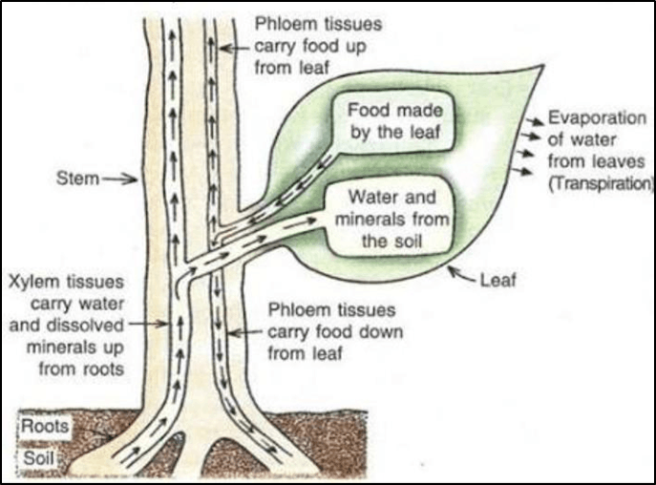

* The transportation of food (or translocation) takes place by utilizing energy.
* The sugar (food) made in leaves is loaded into the sieve tubes of phloem tissue by using energy from ATP. Water now enters into sieve tubes containing sugar by process of osmosis due to which pressure in the phloem tissue increases.
* This high pressure produced in the phloem tissue move the food to all the parts of the plant having less pressure in their tissue.
* Translocation is a bidirectional process. The food moves in both directions, from leaves to stem and roots(downward) and in spring season the sugar stored in root or stem is transported through phloem to buds which need energy to grow(upward).

