* Transportation is the movement of any substance from place where it is synthesized or absorbed to all other parts.
* In plants xylem and phloem are two conducting tissues. Xylem helps in transport of water and phloem helps in transport of food.
* Xylem is made up of four components- tracheids, vessels, xylem fibers, xylem parenchyma. Only xylem parenchyma is the living component.
* Phloem includes four types of cells i.e. sieve tubes, companion cells, phloem fiber, and phloem parenchyma. All cells are living except Phloem fibers which are dead. They have a thick wall and lacks a cytoplasm.
* Mechanism of Transport of water in plants:-

1. Root Pressure Theory
2. Transpiration pull

Root Pressure Theory

* Root pressure is the phenomena that occurs in plant roots, where water and minerals are pushed upward from roots to stem and leaves.
* By the process of osmosis water and minerals move from soil (region of higher concentration) to root (region of low concentration).

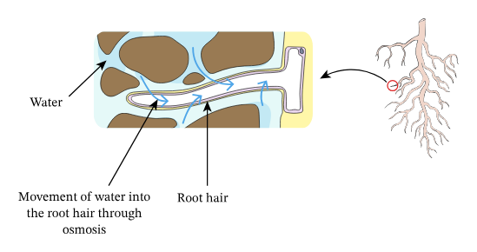

* As the water enters the epidermal cells of the root ,they become turgid (swollen). These turgid cells exert pressure on the adjacent cells. This is called root pressure.

Lateral transportation of water in root is as follows:-

Epidermis- root cortex -endodermis-root xylem.

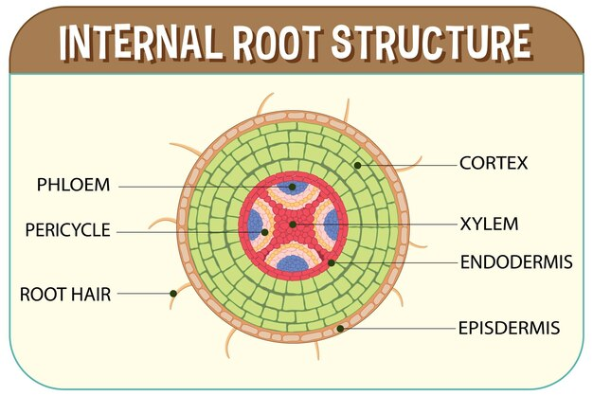

* Under the effect of this pressure water and minerals reach to the Xylem of roots .To reduce the concentration difference in the xylem vessel of plant water and minerals are continuously Pushed forward from roots which forms a continuous water column.
* Root Pressure can lift up water only in small plants.
* Root pressure is typically observed in conditions where transpiration is low (at night )or during period of high soil moisture.

Transpiration Pull

* Transpiration is the loss of water from leaves of a plant.
* Transpiration takes place through stomata which are the tiny small pores guarded by guard cells.
* water evaporates from leaves through stomata as a result water level in the epidermal layer of the leaf decreases.
* Water is brought up to the leaves through the Xylem to compensate for the lost water and a continuous column of water is formed that moves up in Xylem.
* During daytime when stomata are open transpiration pull became major driving force in the movement of water in the xylem.