Excretion

The process of removal of toxic wastes from the body of an Organism is called excretion.

Excretion in Plants

* Like animals plants also produce a number of waste products during their life processes.
* The main waste products produced by plants are carbon dioxide, water vapours and oxygen. Carbon dioxide and Water vapours are produced as waste during respiration by plants whereas oxygen is produced as a waste during photosynthesis. The plants get rid of gaseous waste products through stomata in leaves and lenticels in stem.
* Plants get rid of excessive water by transpiration.
* The plants also store some of waste products in their body parts. For example some of the waste products collect in the leaves ,bark and fruits of the plant or trees. The plants get rid of these waste by shedding of the leaves peeling of bark and felling of fruits.
* The plants also secrete their waste in form of gum and raisins from their stems and branches.
* The plants also excrete some waste substances into the soil around them.

Excretion in Humans

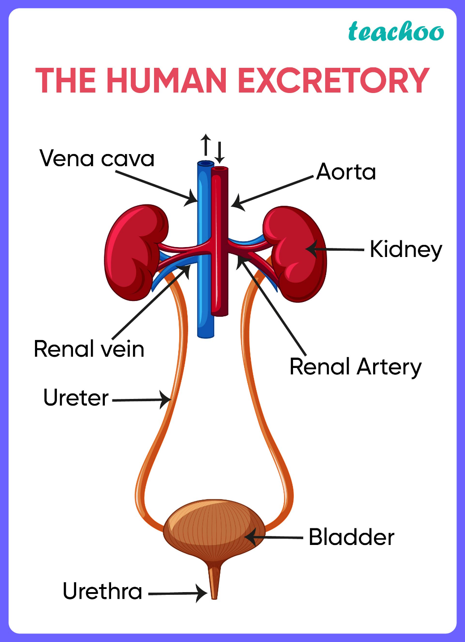

The excretory system of human beings consists of:-

1. Two kidneys
2. Two ureters
3. Urinary bladder
4. Urethra

* **Kidneys**

1. These are bean-shaped filtration organs, which remove urea, other waste salts and excess water from the blood in the form of urine (yellow liquid waste).
2. Humans have 2 kidneys. Each kidney is made up of a large number of excretory units called nephrons. Nephrons are the structural and functional unit of kidneys.
3. Nephrons have a cup shaped bowman's capsule at the upper end. The lower end of the nephron is a tubule. Thus,

Nephron = Bowman's capsule + Tubule

1. One end of the tubule is connected to the bowman's capsule and the other to the urine collecting duct of the kidney.
2. Bowman's capsule has a number of small blood capillaries called glomerulus.
3. One end of the glomerulus is attached to the renal artery which brings the dirty blood containing the urea waste into it. The other end of glomerulus comes out of bowman's capsule as a blood capillary which surrounds the tubule of nephron and finally joins a renal vein( having urea free clean blood ).

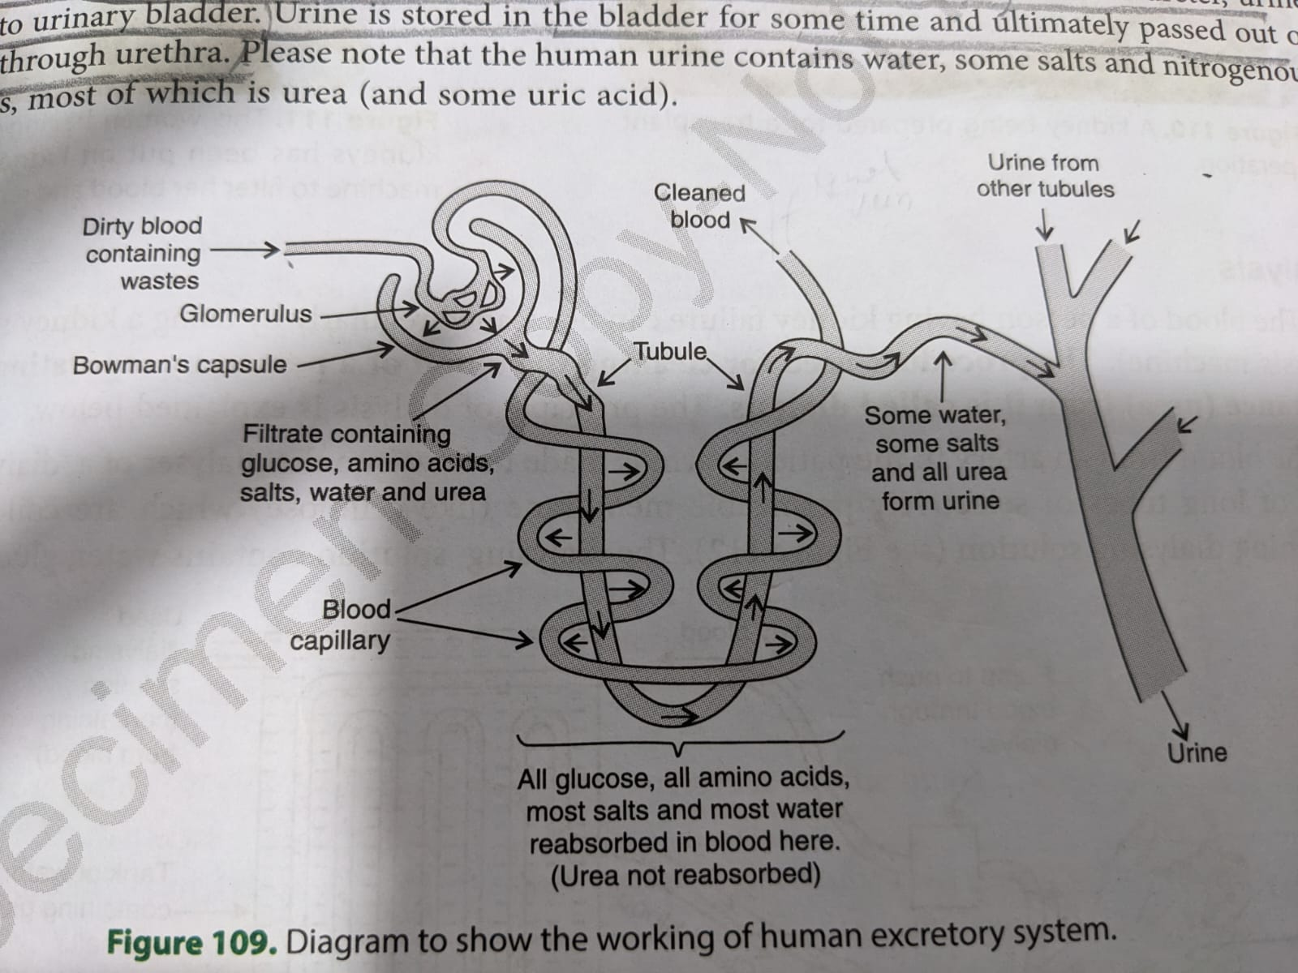

* **Ureters**

These are two tubes which carry urine from each kidney, and open into the urinary bladder. They are about 25 cm long and have a diameter of 3-4 mm .

* **Urinary bladder**

A stretchable bag which stores urine until the brain signals to release it.

* **Urethra**

Urine is passed out from the body through the urethra.

**Process of Excretion**

1. The Dirty blood containing waste like urea (brought by renal artery) enters the glomerulus . The glomerulus filter this blood. During filtration, the substances like glucose, amino acids ,salts ,water and urea etc. present in the blood pass into the Bowman’s capsule and then enter the tubule of nephron.
2. The filtrate containing useful substances as well as the waste substances passes through the tubule, then the useful substances like all glucose, all amino acids, most salts and most water etc are reabsorbed into the blood through blood capillaries surrounding the tubule.
3. Only the waste substances urea, some unwanted salts and excess water remain behind in the tubule.
4. The liquid left behind in the tubule of nephron is called urine. The nephron carries this urine into the collecting duct of the kidneys from where it is carried to ureter.
5. From the ureter ,urine passes into urinary bladder. Urine is stored in the bladder for sometime and ultimately passed out from the body through urethra.

Artificial kidney (Hemodialysis)

* In case of kidney failure, an artificial kidney can be used. An artificial kidney is a device to remove nitrogenous waste products from the blood through dialysis.
* Artificial kidneys contain a number of tubes with a semi-permeable lining(like cellulose), suspended in a tank filled with dialysing fluid. This fluid has the same osmotic pressure as blood. The patient's blood is passed through these tubes.
* During this passage. the waste products from the blood pass into dialysing fluid by diffusion.
* The purified blood is pumped back into the patient. This is similar to the function of the kidney, but it is different since there is no reabsorption involved