**TYPES OF FRACTURES**

**What is a fracture?**

A fracture is a partial or complete break in the bone. When a fracture happens, it’s classified as either open or closed:

* **Open fracture (also called compound fracture):**The bone pokes through the skin and can be seen, or a deep wound exposes the bone through the skin.
* **Closed fracture (also called simple fracture).**The bone is broken, but the skin is intact.

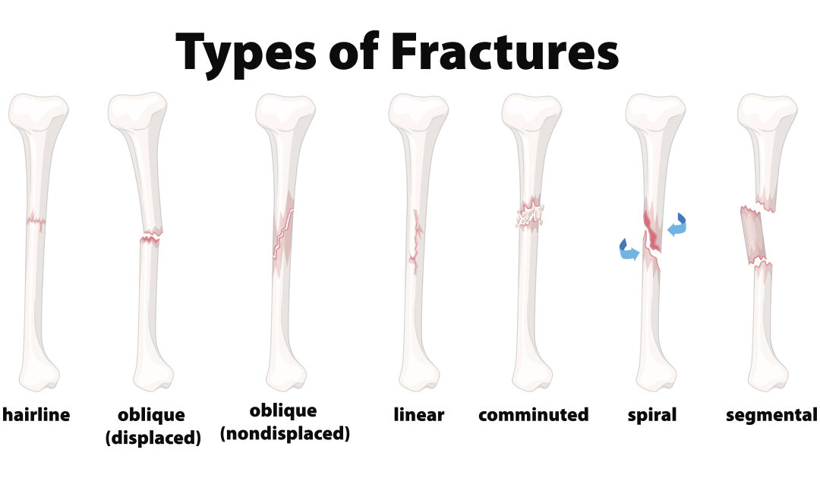

Fractures have a variety of names. Here is a listing of the common types that may happen:

**Stress Fracture**. Stress fractures look like a hairline crack in the bone and can be hard to see on a regular X-ray. Runners are prone to stress fractures because of the repetitive motion of hitting the pavement.

**Greenstick Fracture**. In a greenstick fracture, the bone bends and breaks, but remains in one piece. This is often seen in children due to their softer, more flexible bones.

**Transverse Fracture.** A transverse fracture is characterized by a horizontal break across the bone. It is often the result of a traumatic event like a car accident.

**Oblique Fracture.** In an oblique fracture, the break has a curved or angled pattern within the bone.

**Comminuted Fracture**. When the bone shatters into three or more pieces it’s known as a comminuted fracture. Sometimes, bone fragments break away and embed in the site of the fracture. High-impact trauma such as a car accident typically causes a comminuted fracture.

**Linear Fracture.** Instead of a horizontal break across the bone, a linear fracture is vertical and parallel to the sides of the bone.

**Compression Fracture.** Compression fractures are the result of a crushing of the bone. This type of fracture typically occurs in the spine when the vertebrae collapse because of bone loss due to osteoporosis.

**Displaced Fracture.** In most fractures, the bone breaks but remains in alignment. With a displaced fracture, the bone breaks in two or more pieces and is shifted out of alignment due to the force of the trauma.

**Spiral Fracture.** The defining characteristic of a spiral fracture is a break that spirals around the bone. It’s frequently seen in the long bones of the body, such as the femur, tibia, or fibula in the legs. The most common causes of a spiral fracture are accidents or sports injuries.

**What can I do to prevent fractures?**

Most fractures are caused by accidents, such as falls, or other injuries. But there are some things you may be able to do to decrease your risk of bone fractures, for instance:

* Follow a healthy diet that includes vitamin D and calcium to keep bones strong.
* Do weight-bearing exercises help to keep bones strong.
* Do not use any form of tobacco. Tobacco and nicotine increase the risk of bone fractures and interfere with the healing process.
* Osteoporosis is a common cause of fractures in older people. Talk to your healthcare provider about your risk of osteoporosis and get treatment if you have it.